# Calculating Forecast Rating Curves for Virtual Stations on Ganges and Brahmaputra River using Jason-3 and Jason-2 Interlaced Data

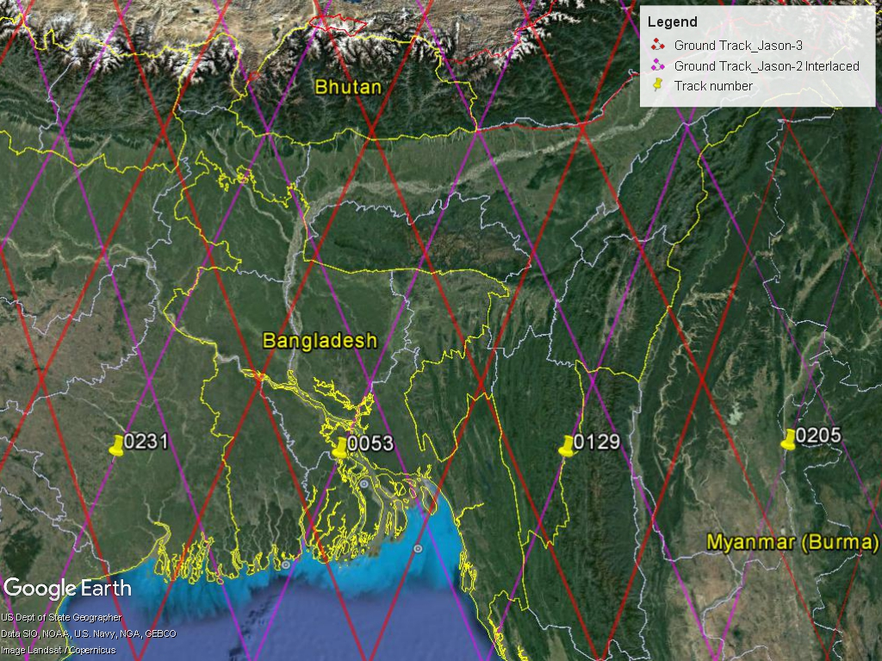

*This task has been completed at the University of Washington, USA at SASWE Research Group under supervision of* ***Dr. Faisal Hossain*** *with assistance from Safat Sikder and Nishan Kumar Biswas*

**Task-1 Completion Report (Draft)**

**April, 2017**

# Introduction:

In October 17, 2016, The Jason-2/OSTM satellite has successfully completed its transfer to the interleaved orbit. The mission is now on the targeted ground track and the Poseidon-3 altimeter is back to operation since October 14th, 2016. From Oct.2016 (at the end of cycle 303), after more than 8 years of service on this nominal ground track, Jason-2 switched to the interleaved orbit that was used by Topex from 2002-2005 and by Jason-1 from 2009-2012. The Jason-3 satellite will continue the long-term climate data record on the primary TOPEX, Jason-1 and Jason-2 ground track.

Jason-3 is the follow-on altimetry mission of Jason-2 / OSTM (launch June 20, 2008) led by the operational agencies: NOAA, EUMETSAT, and CNES. The objective of the Jason-3 Mission is to provide continuity to the unique accuracy and coverage of the TOPEX/Poseidon, Jason-1 and OSTM/Jason-2 missions in support of operational applications related to extreme weather events and operational oceanography and climate applications and forecasting. The details of Jason-3 mission can be explored using the following link.

<https://directory.eoportal.org/web/eoportal/satellite-missions/j/jason-3>

Jason-2 Interlaced and Jason-3 pass ground track can be downloaded as KMZ file from the following Path:

<http://www.aviso.altimetry.fr/en/data/tools/pass-locator.html>

Data can be downloaded from this site

<http://www.aviso.altimetry.fr/en/data/products/sea-surface-height-products/global/gdr-igdr-and-ogdr.html>

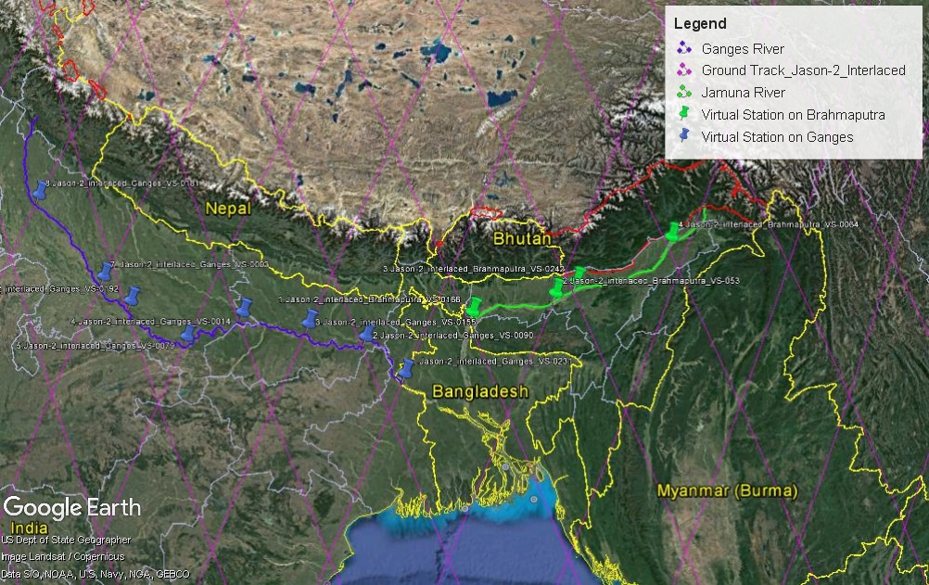

Figure 1: Jason-2 Interlaced Virtual Stations

There are potential 12 nos. Virtual Stations available on Jason-2 interlaced orbits for Ganges and Brahmaputra. Figure 1 shows the potential virtual stations. The list and location is provided in Table1.

Table 1: List of Potential Jason-2 (interlaced) Virtual Stations

|  |  |  |  |
| --- | --- | --- | --- |
| Serial No. | Name of Station | Latitude | Longitude |
| 1 | Jason-2_interlaced_Brahmaputra_VS-0166 | 25°50'16.25"N | 89°47'43.19"E |
| 2 | Jason-2_interlaced_Brahmaputra_VS-053 | 26°13'44.35"N | 91°48'59.23"E |
| 3 | Jason-2_interlaced_Brahmaputra_VS-0242 | 26°28'30.87"N | 92°19'31.59"E |
| 4 | Jason-2_interlaced_Brahmaputra_VS-0064 | 27°23'10.99"N | 94°43'25.99"E |
| 5 | Jason-2_interlaced_Ganges_VS-0231 | 24°29'23.11"N | 88°10'7.41"E |
| 6 | Jason-2_interlaced_Ganges_VS-0090 | 25°16'27.47"N | 87°13'23.35"E |
| 7 | Jason-2_interlaced_Ganges_VS-0155 | 25°31'43.61"N | 85°49'11.00"E |
| 8 | Jason-2_interlaced_Ganges_VS-0014 | 25°43'21.01"N | 84°10'44.53"E |
| 9 | Jason-2_interlaced_Ganges_VS-0079 | 25° 7'11.41"N | 82°47'32.15"E |
| 10 | Jason-2_interlaced_Ganges_VS-0192 | 25°50'16.15"N | 81°17'11.11"E |
| 11 | Jason-2_interlaced_Ganges_VS-0003 | 26°20'21.52"N | 80°31'56.47"E |
| 12 | Jason-2_interlaced_Ganges_VS-0181 | 28° 4'10.71"N | 78°32'16.89"E |

But depending on the influence of the virtual stations on Bangladesh, 7 nos. stations have been chosen for analysis. Jason-2 Interlaced Time-Series Plots have been shown in Figure 3. The list of selected stations, their Lat-Long positions and their Minimum and Maximum Latitude position on both banks are provided in Table2 below.

Table 2: List of 7 nos. Stations Selected for Analysis

|  |  |  |  |  |  |
| --- | --- | --- | --- | --- | --- |
| Sl. | Name of Station | Location | | Min | Max |
| Latitude | Longitude | Latitude | Latitude |
| 1 | Jason-2_interlaced_Brahmaputra_VS-053 | 26.229 | 91.816 | 26.223 | 26.234 |
| 2 | Jason-2_interlaced_Brahmaputra_VS-0242 | 26.475 | 92.325 | 26.454 | 26.534 |
| 3 | Jason-2_interlaced_Brahmaputra_VS-0064 | 27.386 | 94.724 | 27.342 | 27.389 |
| 4 | Jason-2_interlaced_Ganges_VS-0090 | 25.274 | 87.223 | 25.266 | 25.274 |
| 5 | Jason-2_interlaced_Ganges_VS-0155 | 25.529 | 85.820 | 25.496 | 25.538 |
| 6 | Jason-2_interlaced_Ganges_VS-0014 | 25.723 | 84.179 | 25.710 | 25.728 |
| 7 | Jason-2_interlaced_Ganges_VS-0079 | 25.120 | 82.792 | 25.119 | 25.125 |

Based on data availability, 4 nos. Forecast Rating Curves (FRC) have been analyzed for Jason-2 Interlaced orbits. The selected Virtual Stations on Jason-2 interlaced orbits are provided in Table 3. It is importantly mentionable that both Jason-3 and Jason-2 Interlaced orbits have same orbit number although they have different lat-long positions as shown in Figure 2. To avoid confusion between Jason-2 interlaced and Jason-3 virtual stations, a suffix “I” has been used for Jason-2 where the suffix “I” stands for interlaced.

Figure 2: Figure demonstrate orbit number

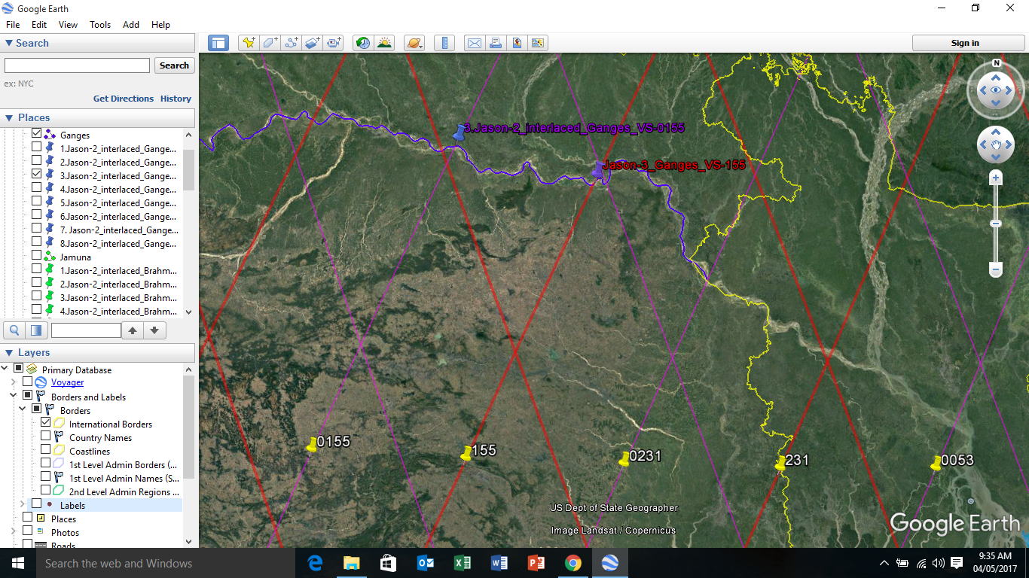

Jason-2 Interlaced Orbit

Jason-3 Orbit

Table 3: Stations analyzed for FRC

|  |  |  |  |
| --- | --- | --- | --- |
| Station ID | River | Latitude | Longitude |
| VS-014_I | Ganges | 25.721 | 84.180 |
| VS-155_I | Ganges | 25.519 | 85.812 |
| VS-064_I | Brahmaputra | 27.365 | 94.734 |
| VS-242_I | Brahmaputra | 26.492 | 92.320 |

# Methodology:

A Mat lab tool “Jason_MyGlobal.exe” developed by Lee et. Al. from University of Houston, USA has been used in this analysis for downloading Geophysical Data Record (GDR) data from Jason-2 Interlaced altimeter and Jason-3 altimeter. However, the tool is not designed for Interim Geophysical Data Record (IGRD), thus the IGDR data has been downloaded manually and placed in the same path where GDR data was kept.

Later, these data have been processed using the same tool. Comparing with measured water level data at Bahadurabad on Jamuna and Hardinge Bridge on Ganges River measured by Bangladesh Water Development Board, Forecast Rating Curves have been developed using scatter plot diagram for 5 Days to 12 Days lead-time.

|  |  |  |
| --- | --- | --- |
|  |  |  |
|  |  |  |
|  |  |  |

Figure 3: Jason-2 Interlaced Time-series Plots

The rating curve equation and plots from 5 to 12 days developed for the Jason-2 Interlaced virtual stations on Ganges and Brahmaputra River are shown in the following tables 4, 5, 6 and 7.

Table 4: Virtual Station 242_I

|  |  |  |  |
| --- | --- | --- | --- |
| Forecast Day Plots | | | |
| 5d, R2= 0.847 |  | 9d, R2= 0.864 |  |
| 6d, R2= 0.859 |  | 10d, R2= 0.869 |  |
| 7d, R2= 0.862 |  | 11d, R2= 0.867 |  |
| 8d, R2= 0.865 |  | 12d, R2= 0.873 |  |

Table 5: Virtual Station 064_I

|  |  |  |  |
| --- | --- | --- | --- |
| Forecast Day Plots | | | |
| 5d, R2= 0.820 |  | 9d, R2= 0.906 |  |
| 6d, R2= 0.844 |  | 10d, R2= 0.898 |  |
| 7d, R2= 0.881 |  | 11d, R2= 0.892 |  |
| 8d, R2= 0.904 |  | 12d, R2= 0.898 |  |

Table 6: Virtual Station 155_I

|  |  |  |  |
| --- | --- | --- | --- |
| Forecast Day Plots | | | |
| 5d, R2= 0.961 |  | 9d, R2= 0.953 |  |
| 6d, R2= 0.961 |  | 10d, R2= 0.949 |  |
| 7d, R2= 0.954 |  | 11d, R2= 0.946 |  |
| 8d, R2= 0.953 |  | 12d, R2= 0.946 |  |

Table 7: Virtual Station 014_I

|  |  |  |  |
| --- | --- | --- | --- |
| Forecast Day Plots | | | |
| 5d, R2= 0.206 |  | 9d, R2= 0.724 |  |
| 6d, R2= 0.192 |  | 10d, R2= 1.0 |  |
| 7d, R2= 0.531 |  | 11d, R2= 0.629 |  |
| 8d, R2= 0.525 |  | 12d, R2= 0.637 |  |

**Jason-3**

There are already 7nos. Virtual Stations available on Jason-3 orbits for Ganges and Brahmaputra River which are functional at this stage. However, these stations forecast rating curves have been re-calculated with latest data set starting from 1st January, 2016 to March 15, 2017. The newly calculated Forecast Rating Curves of Jason-3 virtual stations are provided in the following tables from table 8 to table 13 and locations of virtual stations are shown in figure 4. Jason-3 Time-Series Plots have been shown in Figure 5. Although Virtual Station 192 has been used previously, this station has not been re-calculated as there is insufficient data for this station. Once the virtual station data will be available, this station will be recalculated. In addition, Virtual Station 064 shows very poor correlation, thus discarded from re-calculation and plotting. Table

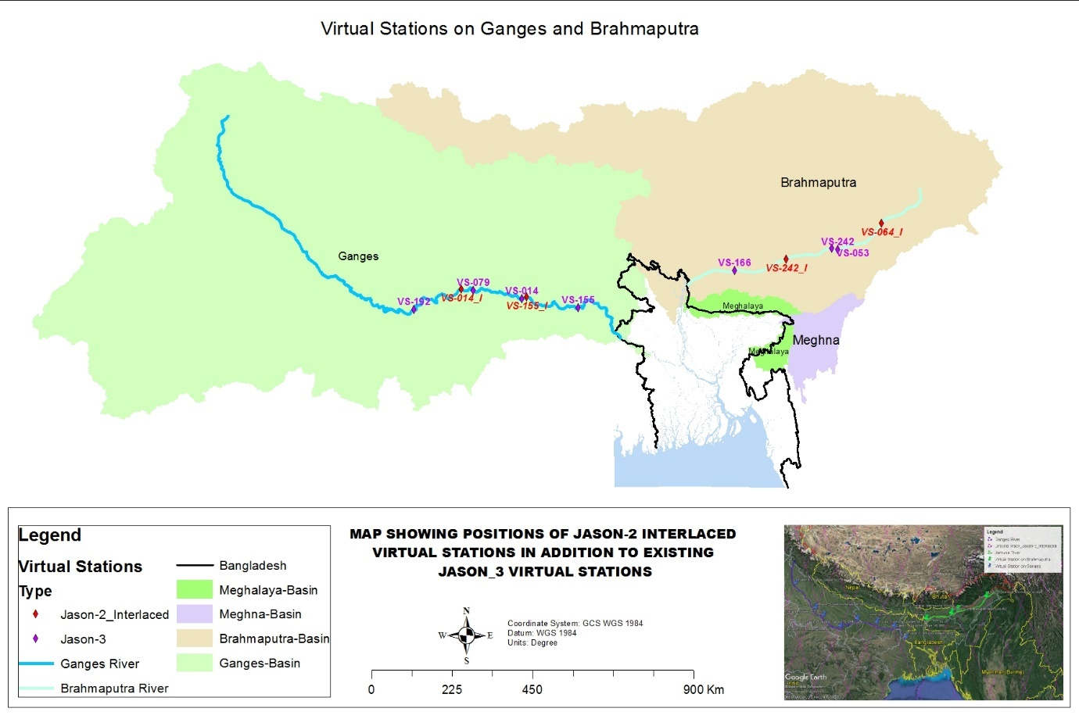

Figure 4: Map Showing Jason-2 Interlaced Virtual Stations in addition to Jason-3 Virtual Stations

Table 8: List of Jason-3 Virtual Stations and their Lat-Long Positions

|  |  |  |  |  |  |
| --- | --- | --- | --- | --- | --- |
|  |  | Location | | Min | Max |
| Sl. | Name of Station | Latitude | Longitude | Latitude | Latitude |
| 1 | Jason-3_Brahmaputra_VS-166 | 26.198 | 91.035 | 26.197 | 26.236 |
| 2 | Jason-3_Brahmaputra_VS-053 | 26.752 | 93.477 | 26.747 | 26.756 |
| 3 | Jason-3_Brahmaputra_VS-242 | 26.720 | 93.620 | 26.696 | 26.741 |
| 4 | Jason-3_Brahmaputra_VS-064 | 28.215 | 95.722 | 28.147 | 28.280 |
| 5 | Jason-3_Ganges_VS-155 | 25.265 | 87.108 | 25.241 | 25.311 |
| 6 | Jason-3_Ganges_VS-014 | 25.488 | 85.700 | 25.480 | 25.520 |
| 7 | Jason-3_Ganges_VS-079 | 25.702 | 84.475 | 25.694 | 25.704 |
| 8 | Jason-3_Ganges_VS-192 | 25.214 | 82.989 | 25.202 | 25.215 |

|  |  |  |
| --- | --- | --- |
|  |  |  |
|  |  |  |
|  |  |  |

Figure 5: Jason-3 Time-series Plots

The rating curve equation and plots from 5 to 12 days developed for the Jason-3 virtual stations on Ganges and Brahmaputra River are shown in the following tables 9 to 14.

Table 9: Virtual Station 014

|  |  |  |  |
| --- | --- | --- | --- |
| Forecast Day Plots | | | |
| 5d, R2= 0.9184 |  | 9d, R2= 0.9064 |  |
| 6d, R2= 0.9169 |  | 10d, R2= 0.8886 |  |
| 7d, R2= 0.9137 |  | 11d, R2= 0.8726 |  |
| 8d, R2= 0.909 |  | 12d, R2= 0.8562 |  |

Table 10: Virtual Station 079

|  |  |  |  |
| --- | --- | --- | --- |
| Forecast Day Plots | | | |
| 5d, R2= 0.6066 |  | 9d, R2= 0.555 |  |
| 6d, R2= 0.6069 |  | 10d, R2= 0.5422 |  |
| 7d, R2= 0.5947 |  | 11d, R2= 0.5188 |  |
| 8d, R2= 0.5705 |  | 12d, R2= 0.4851 |  |

Table 11: Virtual Station 155

|  |  |  |  |
| --- | --- | --- | --- |
| Forecast Day Plots | | | |
| 5d, R2= 0.9162 |  | 9d, R2= 0.877 |  |
| 6d, R2= 0.9067 |  | 10d, R2= 0.8686 |  |
| 7d, R2= 0.8925 |  | 11d, R2= 0.8619 |  |
| 8d, R2= 0.8898 |  | 12d, R2= 0.8553 |  |

Table 12: Virtual Station 053

|  |  |  |  |
| --- | --- | --- | --- |
| Forecast Day Plots | | | |
| 5d, R2= 0.9472 |  | 9d, R2= 0.9394 |  |
| 6d, R2= 0.9401 |  | 10d, R2= 0.9198 |  |
| 7d, R2= 0.9508 |  | 11d, R2= 0.8761 |  |
| 8d, R2= 0.9505 |  | 12d, R2= 0.807 |  |

Table 13: Virtual Station 166

|  |  |  |  |
| --- | --- | --- | --- |
| Forecast Day Plots | | | |
| 5d, R2= 0.9611 |  | 9d, R2= 0.9201 |  |
| 6d, R2= 0.9519 |  | 10d, R2= 0.9096 |  |
| 7d, R2= 0.9423 |  | 11d, R2= 0.9003 |  |
| 8d, R2= 0.9316 |  | 12d, R2= 0.8794 |  |

Table 14: Virtual Station 242

|  |  |  |  |
| --- | --- | --- | --- |
| Forecast Day Plots | | | |
| 5d, R2= 0.9718 |  | 9d, R2= 0.9263 |  |
| 6d, R2= 0.9634 |  | 10d, R2= 0.9266 |  |
| 7d, R2= 0.9549 |  | 11d, R2= 0.9171 |  |
| 8d, R2= 0.9474 |  | 12d, R2= 0.9109 |  |

**Findings:**

The following are the findings of this analysis:

1. Jason-2 Interlaced Virtual Stations no. 064_I, 155_I and 242_I can be used in addition to existing Jason-3 Virtual Stations for the flood forecasting of Bangladesh up to 12 days as these stations show good R2 value ranges from 0.82 to 0.96.
2. Jason-2 Interlaced Virtual Station no. 014_I show poor correlation as observed data are missing. Correlation could be improved thus could be used as another potential virtual station if observed data could be filled and more comparable data is available.
3. Jason-3 Virtual Station 064 shows very poor correlation, thus cannot be considered for flood forecasting of Bangladesh.
4. Although Virtual Station 192 has been used previously, this station has not been re-calculated as there is insufficient data for this station and need to re-calculate once data is available for this station.
5. The Mat lab tool is designed for GDR data cycle, not for IGDR data. This must be updated.
6. There is a gap between Cycle 303 and 305 which interrupts continuous data downloading using Mat lab tool. This issue must be resolved.